4

4-bit binary adder and subtractor and multiplicator

DLD SEP SUBMITTED TO SIR REHAN 20TH MARCH, 2019

TALHA SALMAN FASIH MALIK MUHAMMAD SAAD

18-SE-80 18-SE-86 18-SE-88

**4-bit Binary Adder and Subtractor**

**Introduction**

A 4-bit Binary Adder and Subtractor is a circuit which can take 2, 4-bit binary numbers as input from the user and then perform addition or subtraction on those numbers and show the output using LEDs. It is a basic binary calculator. The operations of both addition and subtraction can be performed by a one common binary adder. Such binary circuit can be designed by adding an Ex-OR gate with each full adder. The mode input control line M is connected with carry input of the least significant bit of the full adder. This control line decides the type of operation, whether addition or subtraction. When M= 1, the circuit is a subtractor and when M=0, the circuit becomes adder.

**Apparatus**

* 1 x OR (7432)
* 2 x AND (7408)
* 3 x XOR (7486)
* 1 x DIP Switch (8 input)
* 5 x LEDs
* 5 x 1k Ω resistors
* 1 x 9V battery
* Breadboards

**Procedure**

1. First of all, we will make sure that all the apparatus is in working condition.
2. Now we will construct 4 Full Adder circuits, placed parallel to each other as shown by the Block diagram.
3. We will XOR our 4 B inputs with a common input M, which will act as our control line to switch between adder and subtractor modes. M is also connected to carry input of our least significant bit.
4. Carry out is connected to carry in of next adder circuit.
5. Most significant carry out, S3, S2, S1 and S0 will give us our outputs, which will each be connected to an LED to show output.
6. The LEDs are connected to our resistors to prevent burnout and then ground.
7. Lastly, we connect out inputs A3, A2, A1, A0, B3, B2, B1, B0 to a 8 bit DIP switch, and also a single input switch for control line M.
8. Then we will test our circuit for outputs and errors.

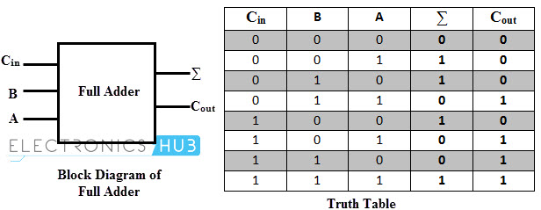**Figures and Truth Table**

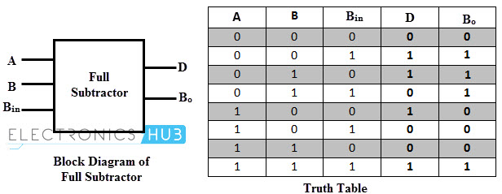

**Schematic Diagrams**

*To be added after simulation*

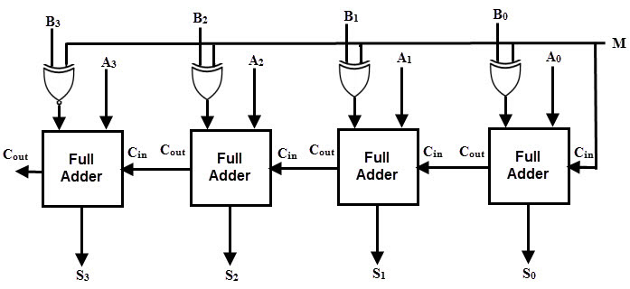**Block Diagram**

**Outputs**

*To be added after simulation and implementation*

**Future Work**

This circuit can be extended to a 8-bit or even a 16-bit version but of course, with that comes complexity and higher requirements.

**Multiplicator**

**ADDER IC SN74LS83N**

